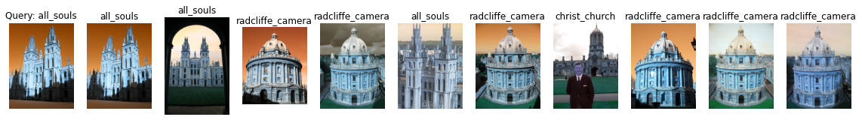

Label: all_souls

Average Precision for query 0: 0.2448444535623903

Precision@k for query 0: 0.3

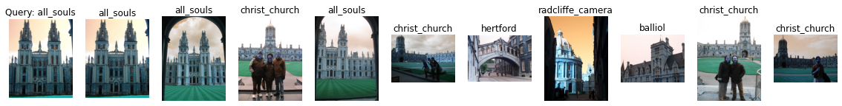

Label: all_souls

Average Precision for query 1: 0.21557492644335907

Precision@k for query 1: 0.3

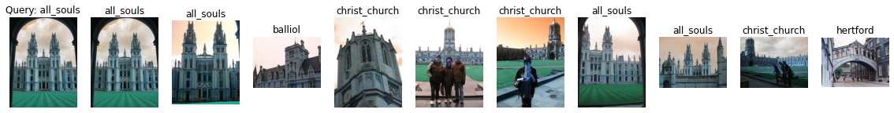

Label: all_souls

Average Precision for query 2: 0.20623208065673865

Precision@k for query 2: 0.4



Label: all_souls

Average Precision for query 3: 0.4100532367913514

Precision@k for query 3: 0.8

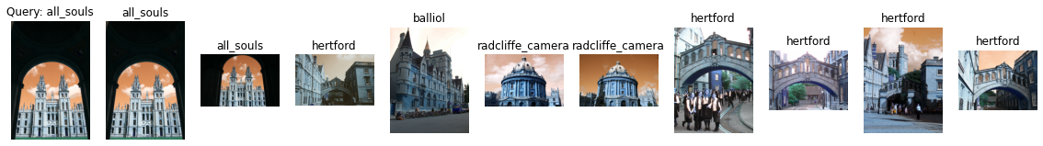

Label: all_souls

Average Precision for query 4: 0.16430175445682543

Precision@k for query 4: 0.2

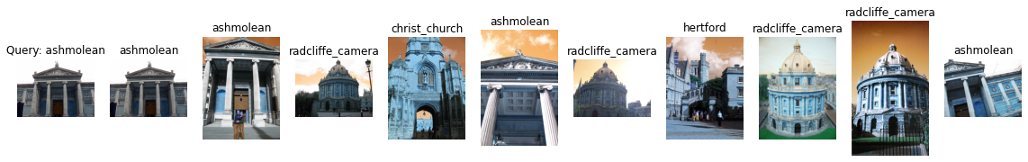

Label: ashmolean

Average Precision for query 5: 0.1766270993303136

Precision@k for query 5: 0.4

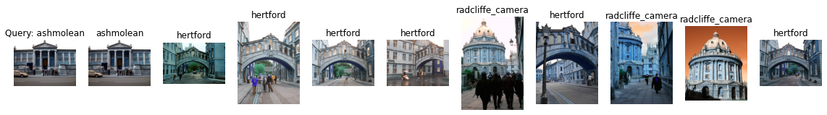

Label: ashmolean

Average Precision for query 6: 0.08402518415178699

Precision@k for query 6: 0.1

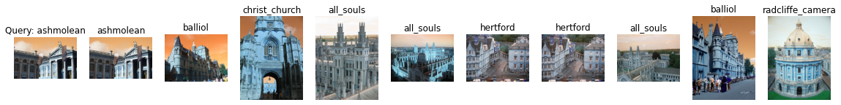

Label: ashmolean

Average Precision for query 7: 0.07473602902538463

Precision@k for query 7: 0.1

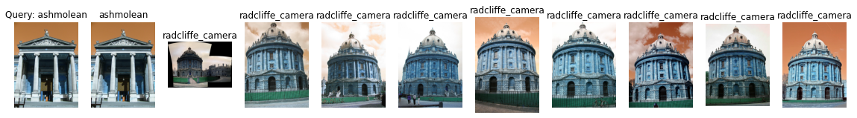

Label: ashmolean

Average Precision for query 8: 0.1004083048116811

Precision@k for query 8: 0.1

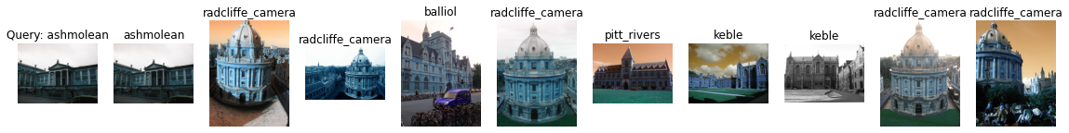

Label: ashmolean

Average Precision for query 9: 0.07513124331994868

Precision@k for query 9: 0.1

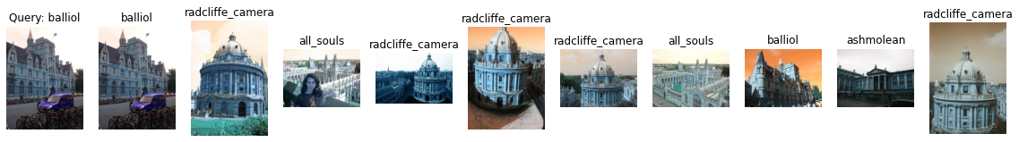

Label: balliol

Average Precision for query 10: 0.16506647953004808

Precision@k for query 10: 0.2

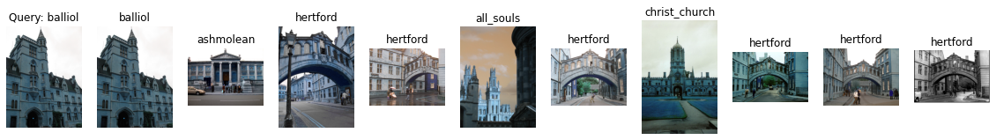

Label: balliol

Average Precision for query 11: 0.12825276921970052

Precision@k for query 11: 0.1

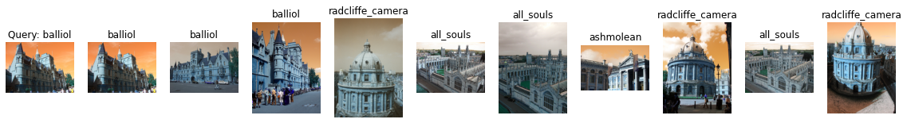

Label: balliol

Average Precision for query 12: 0.3203056874531515

Precision@k for query 12: 0.3

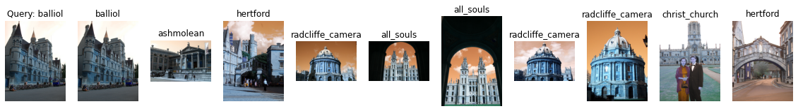

Label: balliol

Average Precision for query 13: 0.132761095371668

Precision@k for query 13: 0.1

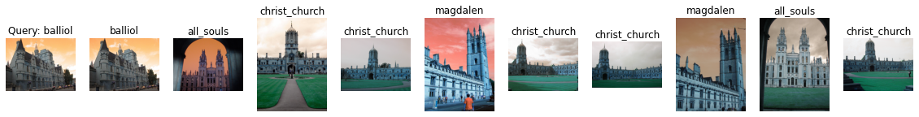

Label: balliol

Average Precision for query 14: 0.12865580482922276

Precision@k for query 14: 0.1

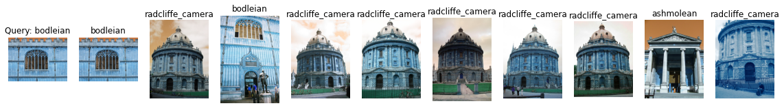

Label: bodleian

Average Precision for query 15: 0.1273362017218427

Precision@k for query 15: 0.2

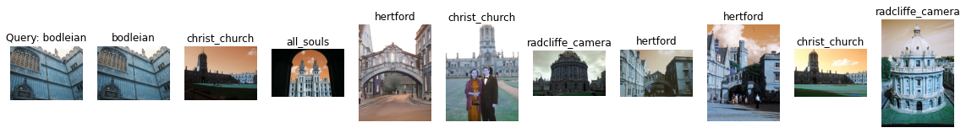

Label: bodleian

Average Precision for query 16: 0.07530497056926051

Precision@k for query 16: 0.1

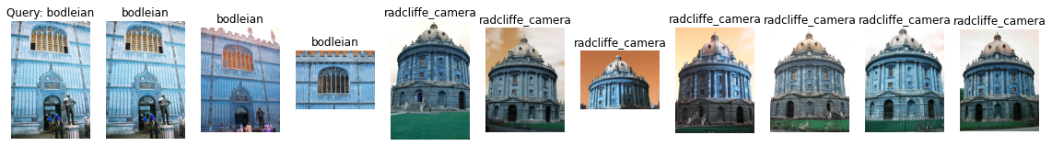

Label: bodleian

Average Precision for query 17: 0.19736124617649461

Precision@k for query 17: 0.3

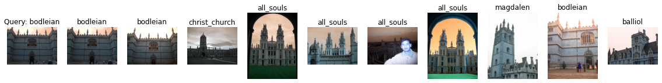

Label: bodleian

Average Precision for query 18: 0.1905167414596268

Precision@k for query 18: 0.3

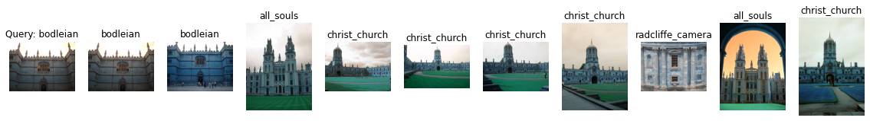

Label: bodleian

Average Precision for query 19: 0.19634916441379793

Precision@k for query 19: 0.2



Label: christ_church

Average Precision for query 20: 0.2584637659692828

Precision@k for query 20: 0.7

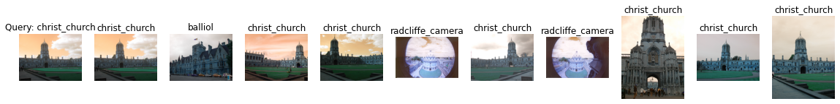

Label: christ_church

Average Precision for query 21: 0.3242731807176378

Precision@k for query 21: 0.7

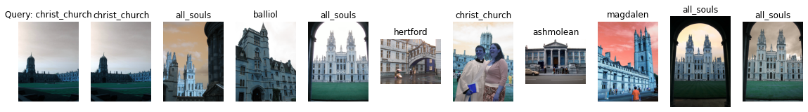

Label: christ_church

Average Precision for query 22: 0.23643550395174323

Precision@k for query 22: 0.2

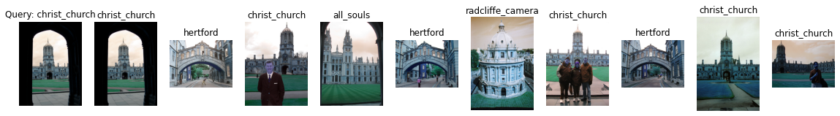

Label: christ_church

Average Precision for query 23: 0.20163302161310712

Precision@k for query 23: 0.5

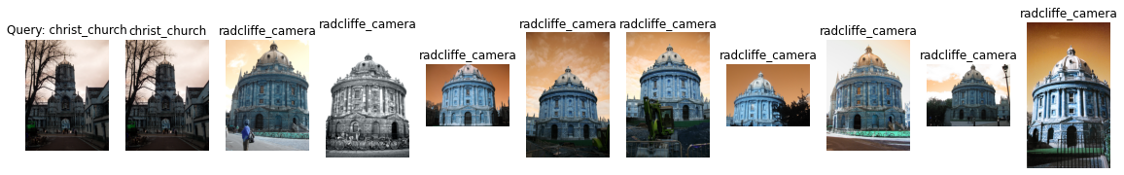

Label: christ_church

Average Precision for query 24: 0.11030405486428155

Precision@k for query 24: 0.1

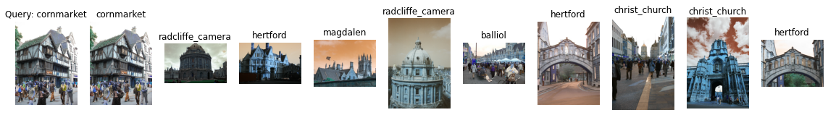

Label: cornmarket

Average Precision for query 25: 0.13396802042334832

Precision@k for query 25: 0.1

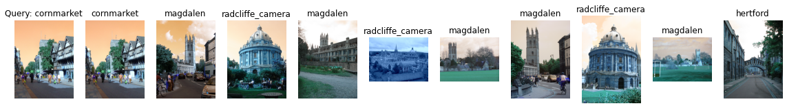

Label: cornmarket

Average Precision for query 26: 0.13934271922142177

Precision@k for query 26: 0.1

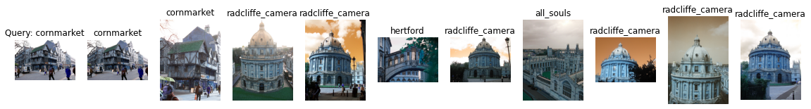

Label: cornmarket

Average Precision for query 27: 0.23770293603051806

Precision@k for query 27: 0.2

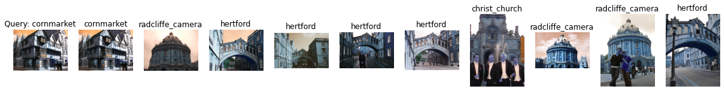

Label: cornmarket

Average Precision for query 28: 0.128936241153156

Precision@k for query 28: 0.1

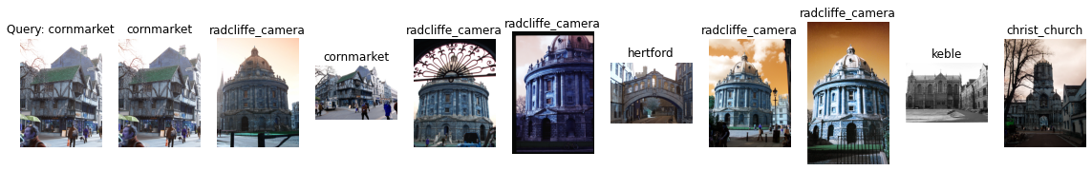

Label: cornmarket

Average Precision for query 29: 0.19940350869357742

Precision@k for query 29: 0.2

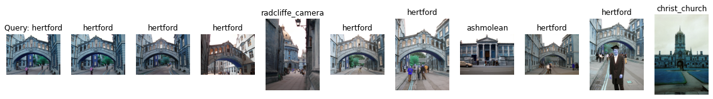

Label: hertford

Average Precision for query 30: 0.4702236579826995

Precision@k for query 30: 0.7

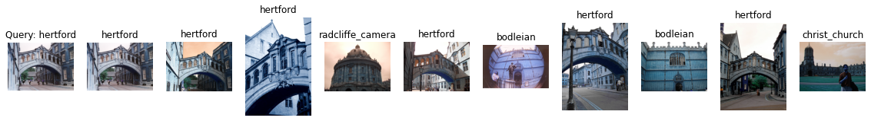

Label: hertford

Average Precision for query 31: 0.43445213941070304

Precision@k for query 31: 0.6

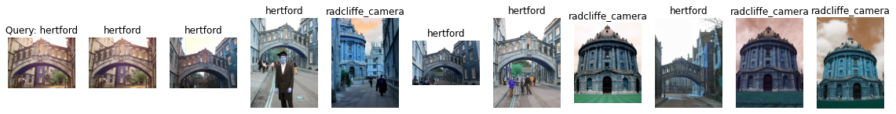

Label: hertford

Average Precision for query 32: 0.32076809777467963

Precision@k for query 32: 0.6

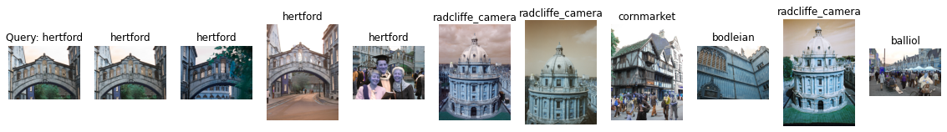

Label: hertford

Average Precision for query 33: 0.21776994465370927

Precision@k for query 33: 0.4

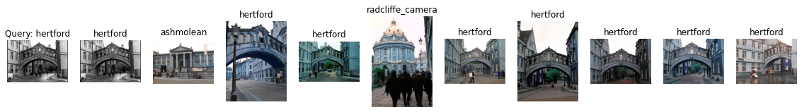

Label: hertford

Average Precision for query 34: 0.4964258833372366

Precision@k for query 34: 0.8



Label: keble

Average Precision for query 35: 0.9136577708006278

Precision@k for query 35: 0.6

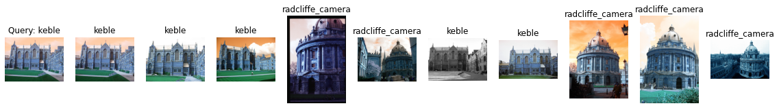

Label: keble

Average Precision for query 36: 0.7154607297464439

Precision@k for query 36: 0.5

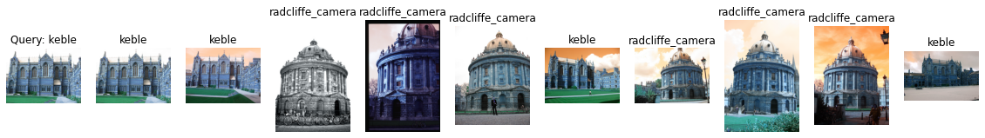

Label: keble

Average Precision for query 37: 0.5127772848269743

Precision@k for query 37: 0.4

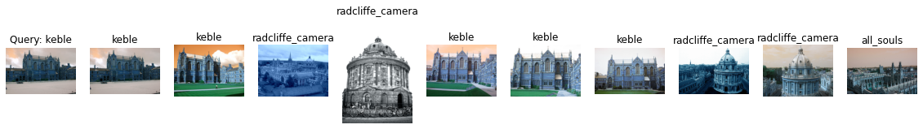

Label: keble

Average Precision for query 38: 0.6307709750566894

Precision@k for query 38: 0.5

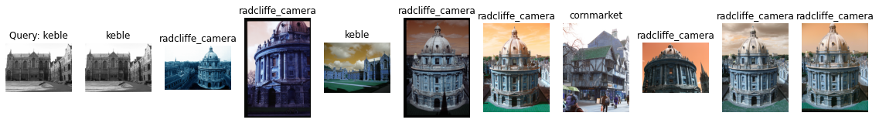

Label: keble

Average Precision for query 39: 0.28673754467192475

Precision@k for query 39: 0.2

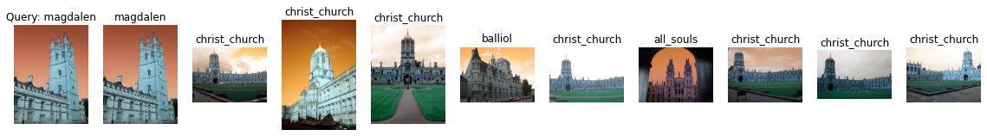

Label: magdalen

Average Precision for query 40: 0.07617335748896169

Precision@k for query 40: 0.1



Label: magdalen

Average Precision for query 41: 0.298044724422534

Precision@k for query 41: 0.5

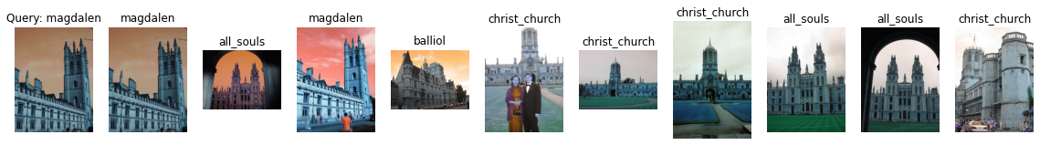

Label: magdalen

Average Precision for query 42: 0.08730542917018962

Precision@k for query 42: 0.2

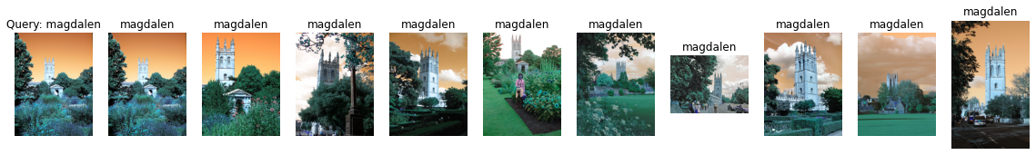

Label: magdalen

Average Precision for query 43: 0.6348955117556133

Precision@k for query 43: 1.0

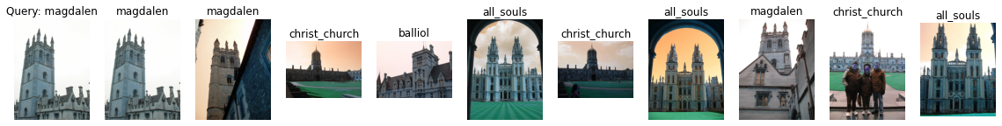

Label: magdalen

Average Precision for query 44: 0.11302462486766846

Precision@k for query 44: 0.3

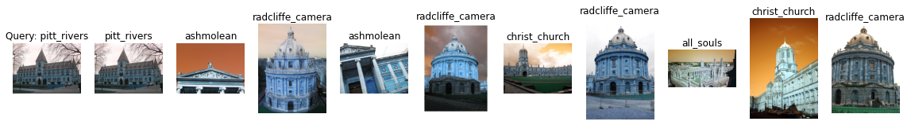

Label: pitt_rivers

Average Precision for query 45: 0.2176812135704134

Precision@k for query 45: 0.1



Label: pitt_rivers

Average Precision for query 46: 0.23680792777699053

Precision@k for query 46: 0.2



Label: pitt_rivers

Average Precision for query 47: 0.17643441392151402

Precision@k for query 47: 0.1

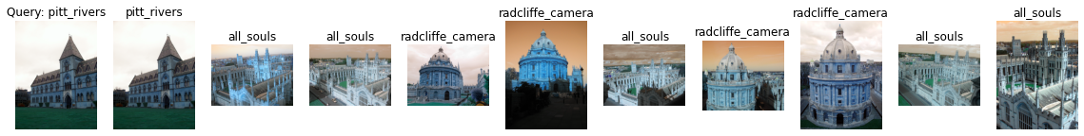

Label: pitt_rivers

Average Precision for query 48: 0.20656942649971574

Precision@k for query 48: 0.1

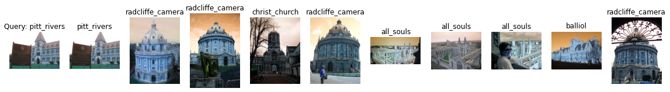

Label: pitt_rivers

Average Precision for query 49: 0.18999496482409325

Precision@k for query 49: 0.1

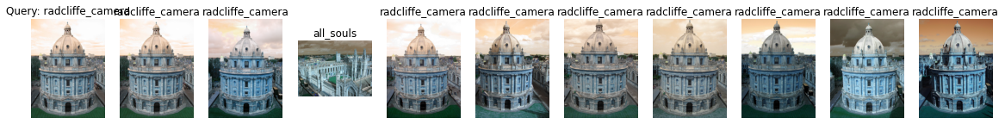

Label: radcliffe_camera

Average Precision for query 50: 0.5704041130668861

Precision@k for query 50: 0.9

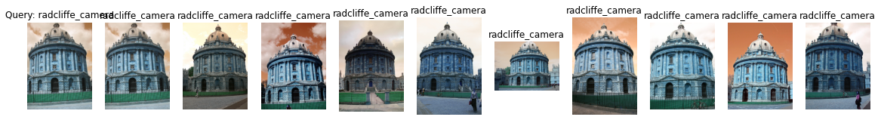

Label: radcliffe_camera

Average Precision for query 51: 0.7015165424466204

Precision@k for query 51: 1.0

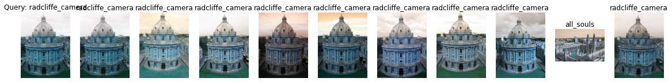

Label: radcliffe_camera

Average Precision for query 52: 0.5637376339865056

Precision@k for query 52: 0.9



Label: radcliffe_camera

Average Precision for query 53: 0.5532972616440227

Precision@k for query 53: 0.7

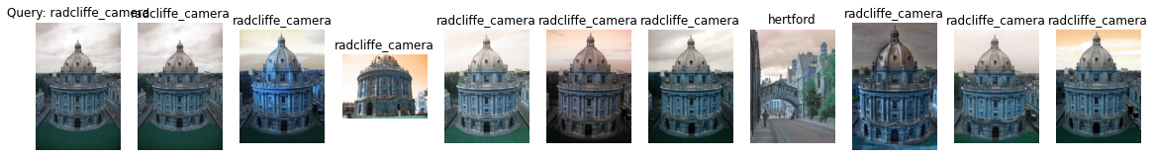

Label: radcliffe_camera

Average Precision for query 54: 0.6470773836714535

Precision@k for query 54: 0.9

mAP = 0.2846602906055916